32. Plot Data Symbols on a Map

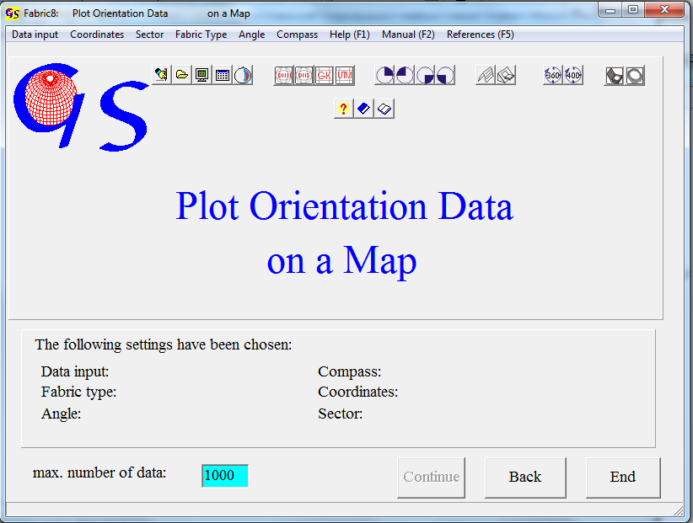
Fig.1

This program (Fig. 1) enables you to plot structural data (planes or lineations) as symbols on a map. It is also possible to plot a stereogram on a map. The stereogram must already exist as a *.GIF-file. In this case the input of geographic coordinates can only be manually.

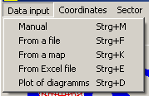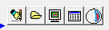
Fig. 2

Input of orientation data (Fig.2), can be manually, from a file, from a map, or from an Excel sheet.
For manual input, input from a map, or from an excel sheet the coordinate type must be set (Fig. 3).

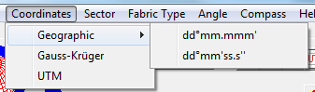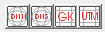
Fig. 3

Geographic coordinates are longitudes and latitudes. Longitudes are great circles through the poles (0°..180°E and 0°..180°W). Latitudes are small circles parallel to the equator (0°..90°N and 0°..90°S). These coordinates may have the format ‘dd°mm.mmm' ’ (e.g. 52°35.567'E) or ‘dd°mm'ss.s'' ‘(e.g. 52° 35'30.5''E).
Gauss-Krüger coordinates were developed by Carl Friedrich Gauss and Johann Heinrich Louis Krüger: They divide the surface of the earth in 3°-wide meridian stripes. Each stripe connects the north pole with the south pole. In the middle of the stripe the middle meridian is localised. Each stripe gets a number defined by the middle meridian (0°, 3°, 6°,... get the numbers 0, 1, 2, ......). The coordinates of a point in a stripe are defined by its ‚easting‘ and ‚northing‘. Easting indicates the distance of the point from the middle meridian in meter. To avoid negative values a value of 500km is added. The northing is the distance from the equator, measured parallel to the middle meridian.
Gauss-Krüger-Koordinaten are used mainly in Europe.
The third type of coordinates are UTM coordinates. UTM means 'Universe Transverse Mercator'. These coordinates were established in 1947. They are used all over the world with exception of the polar regions. They resemble to a certain degree the Gauss-Krüger coordinates, but in UTM one meridian stripe is 6°. The coordinate axes are easting and northing. The earth’s surface is devided into UTM-zone fields. Between 180°W and 180°E the surface of the earth is devided in 60 meridian stripes of 6° width each. Numbering of these stripes is done with zone numbers (1 for the stripe 180°W to 174°W, 60 for the stripe 174°E to 180°E). From 80°S to 84°N the meridian stripes are divided by latitudese in a distance of 8° in zone fields, counted with letters. The southernmost zone has the letter”C” and the northernmost the letter “X” (Letters I and O are let out to avoid confusion with numbers 1 and 0 (s. Fig. 5).

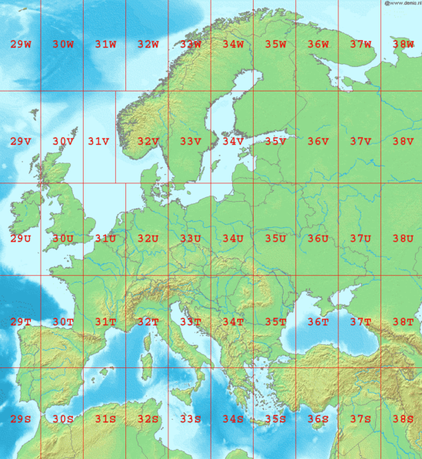
Fig. 5 (aus Wikipedia)

For the geographic coordinates you have to indicate whether longitudes are counted to the east or to the west, and for the latitudes whether they are north or south. This is done in the menu “Sector” (Fig. 6).

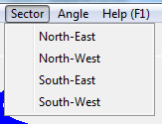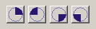
Abb. 6

If input is from an excel sheet, you have to decide wether data are linears or planes (Fig. 7).
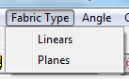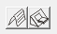
Fig. 7

In the menu "Angle" (Fig. 8) you have to declare whether the data have the scale 0..360° or 0..400gon.

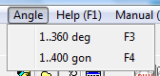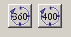
Fig. 8

When you choose ‘Manual input‘ or ‘Input from an excel file‘ the data can be in in the format of a Clar or Brunton compass (Fig. 9).

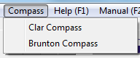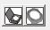
Fig 9

Clar compass: Azimuth and dip angle,
Brunton compass: strike, dip angle, direction of dip (N or S).

The choice of these options is shown on the bottom part of the form. When the options are complete, the button “Continue” becomes active. It brings you to the next form.

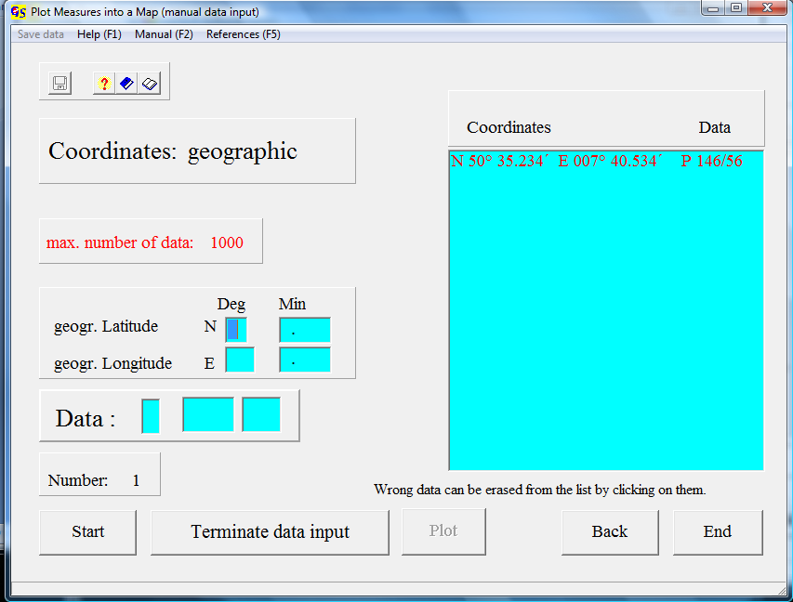
Fig.10

Fig. 10 shows the form for manual input of geographic coordinates in dd°mm.mmm' format after pressing the “Start” button and input of one measure point. The characterization of the measure as plane or linear is done by the letters ‘P’ or ‘L’.
Fig 11 shows the input field for coordinates in dd°mm'ss.s'' format.

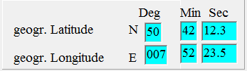
Fig. 11

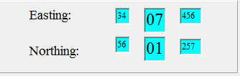
Abb. 12

Fig. 12 shows the input field for Gauss-Krüger coordinates and Fig. 13 that for UTM coordinates.

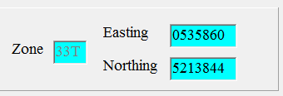
Abb. 13

Press the button “Terminate Input” when all data are typed.
Now the menu “Save Data” becomes active. With the button “Plot” you reach the form on which the map is plotted.

Fig. 14 shows the form for the input of stereograms after input of the radius of the diagrams. Input of coordinates is the same as for single data. When the input of geographic coordinates is completed, the button “Find Diagram” becomes active. Find the folder which contains the *.GIF files and click on the stereogram, you want to put at the point of the map.
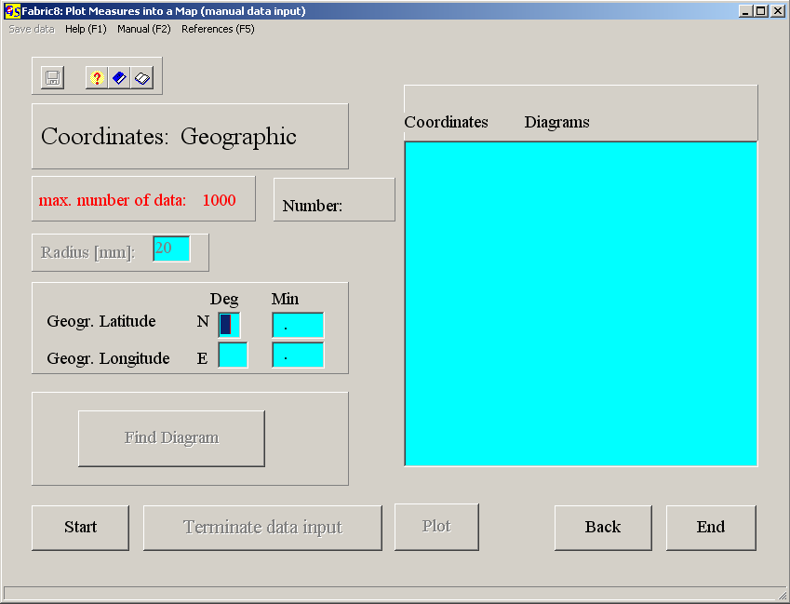
Fig. 14

Fig. 15 shows the form for data input from a file. It shows the same pattern as all other Fabric8 forms for input from a file. Observe that geographic coordinates are always served in the dd°mm.mmm' format. The type of coordinates is written in the first line of the file. It appears in the field “Coordinates”. The extension of data files is *.map.

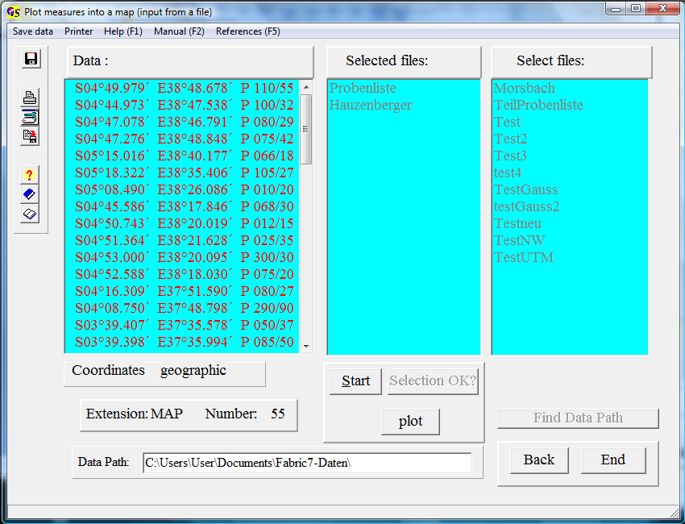
Fig. 15

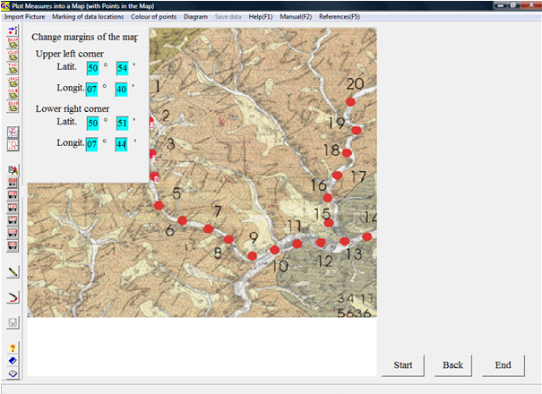
Fig. 16

Fig. 16 shows the form for data input from a map, after import of a map whith the locations of measure points. The map can be imported as *-bmp, *.gif, *.tif, *.jpeg, *.wmf or *.emf file. Choose either 'Whole picture' or 'Cut out' from the menu "Cut out". To cut out a rectangle, click on the upper left edge and on the lower right edge. In the menu “Marking of data location” you have to indicate whether the points are marked on the front side or on the backside of the map.
For the correct calculation of the coordinates of the measure points you have to type the coordinates of the upper wright and the lower left corner of the map. Fig. 15 shows the form after clicking the first four points and input of their measures in the field “Data input”.
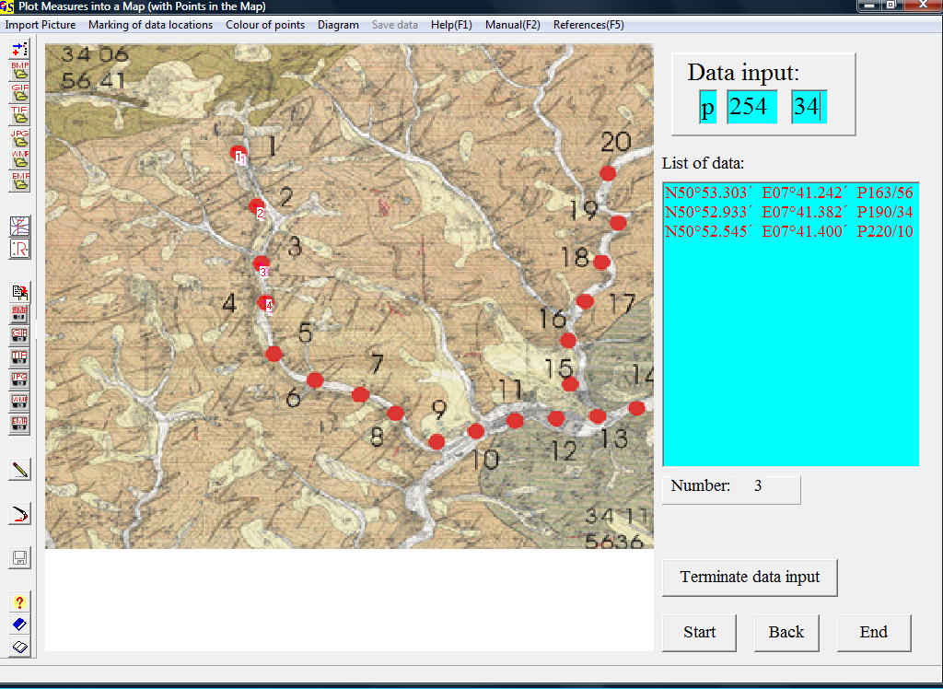
Fig. 17

When data input is finished, press the button ‚”erminate input”. Now the data can be saved in a file.
Fig. 18 shows the map for the data of Fig. 15.

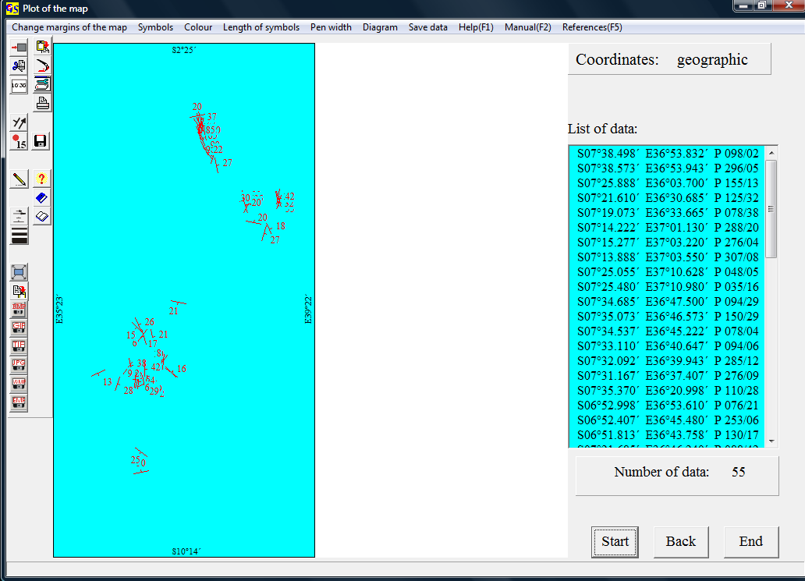
Fig. 18

The data can be projected on a map, satellite image, or digital elevation model.
To do so, go to “Change margins of the map / set margins of the map” (Fig. 19) and write the coordinates of the margins of the map or image in the fields of Fig. 20. Now import the map or the image with “Diagram / Get picture from a file” or “Get picture from clipboard” Fig. 21 shows the image with the measures on it.

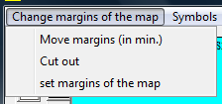 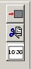 Abb. 19

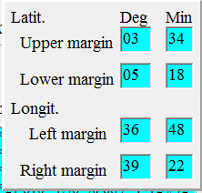 Abb. 20

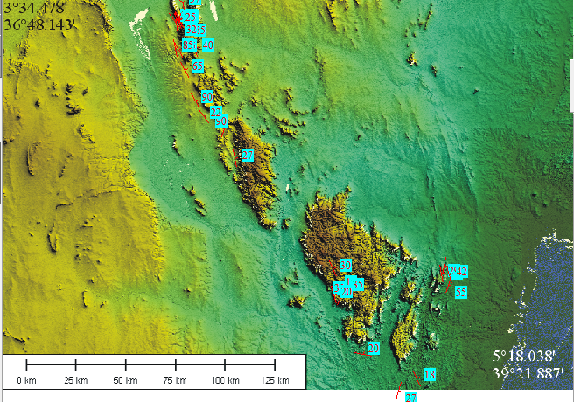
Abb. 21

